SICKNESS / GOING TO THE DOCTOR

*Vocabulary:
1. Back Pain 2. Headache 3. Cold 4. Nausea
5. Toothache 6. Allergies 7. Rash 8. Stomachache
9. Cough 10. Dizziness 11. Fever 12. Earache
13. Vomiting 14. Nasal Congestion 15. Sore Throat

*Vocabulary Activity #1: Match the above vocabulary with the pictures
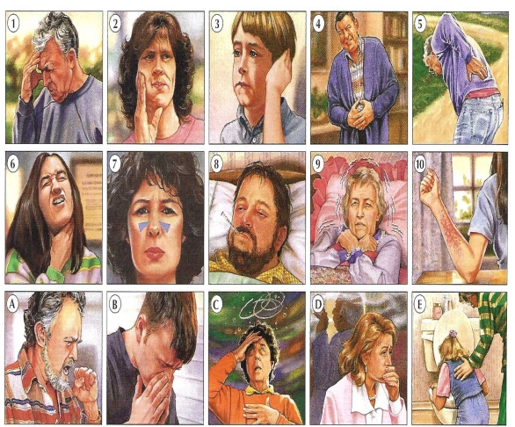

1. ____________ 2. ___________ 3. ___________ 4. ___________ 5. ____________
6. ____________ 7. ___________ 8. ___________ 9. ___________ 10. ____________
A. ___________ B. ___________ C. ___________ D. ___________ E. ___________

2. Match the sentences with the correct image.
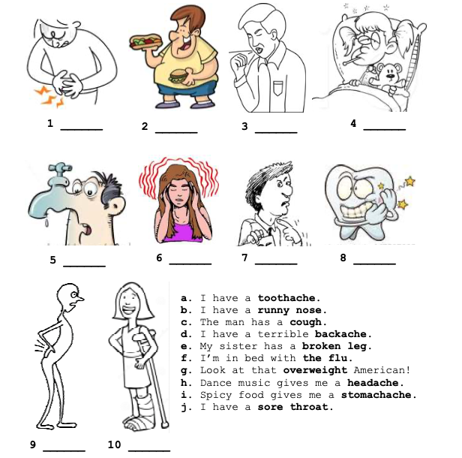

3. Click the link and play the game!

https://www.vocabulary.cl/english-games/health-problems.htm

